МИНИСТЕРСТВО НАУКИ И ВЫСШЕГО ОБРАЗОВАНИЯ РФ
ФГБОУ ВО
Московский авиационный институт
(национальный исследовательский университет)
Кафедра 304
Вычислительные машины, системы и сети

Отчет по лабораторной работе №4
по учебной дисциплине «Базы Данных»

Выполнил студент группы М3О-311Б-21:
Давыдов А.П.
Принял:
Ткачев О.А.
Мурсенков П.А.

Москва 2023

Задания к лабораторной работе

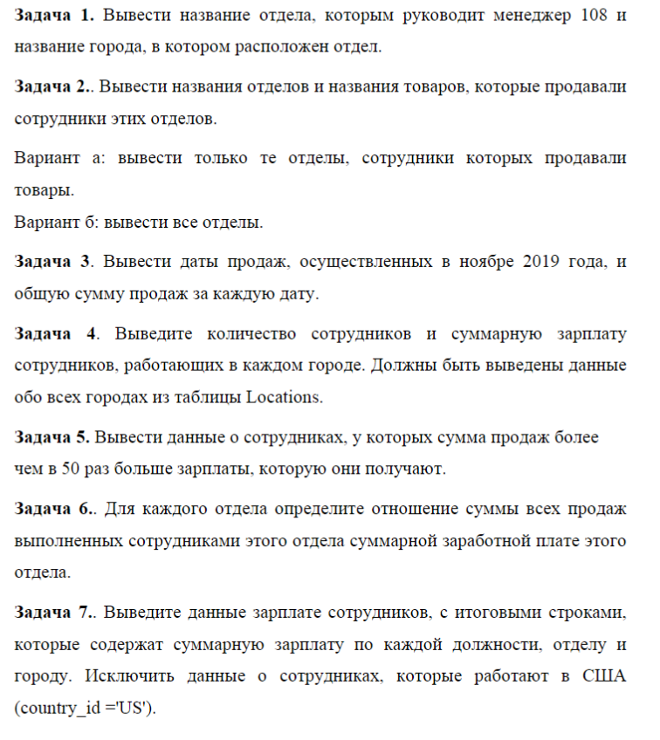
Выполнение
Задание 1
Условие:
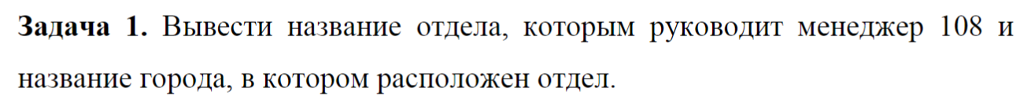
Запрос:
select d.department_name , l.city
from departments d, locations l
where d.manager_id = 108 and d.location_id = l.location_id

Вывод:
department_name|city |
---------------+-------+
Finance |Seattle|

Задание 2
Условие:
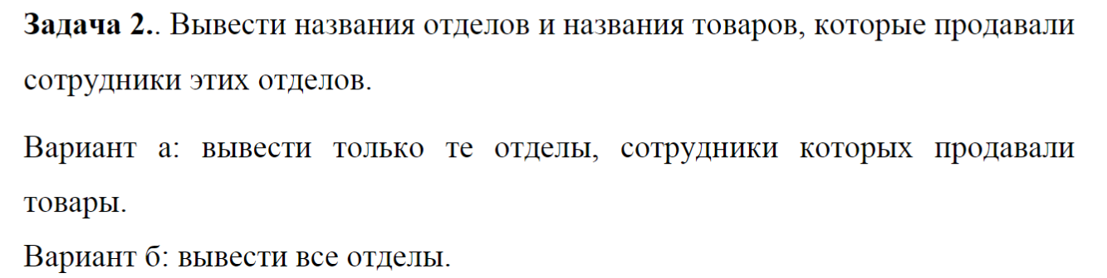
Запрос:
А)
select department_name, p.product_name, (e.first_name || ' ' || e.last_name) as _employee
from departments d join employees e using (department_id)
join orders o on(salesman_id = e.employee_id)
join order_items using (order_id)
join products p using (product_id)
Б) (left outer и одна скобочка для вынесения отделов)
select department_name, p.product_name
from departments d left outer
join (employees e
join orders o on(salesman_id = e.employee_id)
join order_items using (order_id)
join products p using (product_id)) using (department_id)
order by department_name
Вывод:
А)
department_name|product_name |_employee |
---------------+---------------------------------------------------------------+-----------------+
Sales |Kingston HyperX Alloy FPS |Mattea Marvins |
Sales |Dell Inspiron 7567 Black (7567-8821) |Oliver Tuvault |
Sales |Intel Core i7 9700F OEM Coffee Lake Refresh 1151v2 |Allan McEwen |
Sales |Corsair K70 RGB MK.2 Cherry MX Red (CH-9109010-RU) |Louise Doran |
Sales |AMD Athlon 200GE BOX AM4 VEGA 3 APU Raven Ridge (YD200GC6FBBOX)|Sarath Sewall |
Sales |ASUS ROG STRIX B550-E GAMING AM4 |Mattea Marvins |
Sales |Gigabyte 27" Aorus AD27QD-EK |David Lee |
Sales |AMD RYZEN 9 5950X BOX AM4 Vermeer (100-100000059WOF) |Sundar Ande |
Sales |LG V30+ Black (H930DS) |Sundar Ande |
Sales |Asus X99-E-10G WS |Sundar Ande |
Б)
department_name |product_name |
--------------------+---------------------------------------------------------------+
Accounting | |
Administration | |
Benefits | |
Construction | |
{...}
Operations | |
Payroll | |
Public Relations | |
Purchasing | |
Recruiting | |
Retail Sales | |
Sales |AMD Ryzen Threadripper 1920X (X399, TR4) |
Sales |Gigabyte Z490 AORUS PRO AX LGA1200 |
Sales |LG V30+ Black (H930DS) |
Sales |Intel Core i7 10700K OEM Comet Lake LGA1200 (CM8070104282436) |
Sales |A4tech X-710BK USB |
Sales |Acer Predator Helios 300 PH317-51-7717 |
Sales |MSI GP72 7RDX Leopard |
Sales |Razer DeathAdder Elite |
Sales |Intel Xeon E5-2699 V5 (OEM/Tray) |
Sales | Intel Core i5 10600KF OEM Comet Lake LGA1200 (CM8070104282136)|

Задание 3
Условие:
Запрос:
select o.order_date, sum(oi.unit_price * oi.quantity)
from orders o, order_items oi
where extract ('month' from o.order_date) = 11 and extract ('year' from o.order_date)= 2019
and oi.order_id = o.order_id
group by o.order_date

Вывод:
order_date|sum |
----------+---------+
2019-11-01| 61160.00|
2019-11-02|325600.00|
2019-11-23|220400.00|
2019-11-29| 2760.00|

Задание 4
Условие:
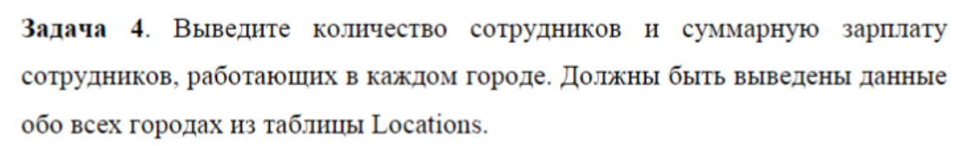
Запрос:
select l.city, count(e.salary) as Amount, sum(e.salary) as summary_salary
from locations l left outer join
(employees e join departments d using (department_id))
using (location_id)
group by l.city

Вывод:
city |amount|summary_salary|
-------------------+------+--------------+
Mexico City | 0| |
Milano | 0| |
Utrecht | 0| |
Bombay | 0| |
Southlake | 5| 28800.00|
Bern | 0| |
London | 1| 6500.00|
South San Francisco| 43| 151100.00|
Beijing | 0| |
Sydney | 0| |

Задание 5
Условие:
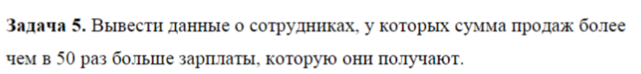
Запрос:
select (e.first_name || ' ' || e.last_name || ' '|| e.email || ' ' || e.phone_number || ' Salary: ' || e.salary ) as Employee,
SUM(oi.quantity * oi.unit_price) as SummarySales
from employees e left outer join
(orders o join order_items oi using (order_id))
on (salesman_id = employee_id)
group by e.first_name, e.last_name, e.email, e.phone_number, e.salary
having SUM(oi.quantity * oi.unit_price) > e.salary * 50

Вывод:
employee |summarysales|
-----------------------------------------------------------+------------+
William Smith WSMITH 011.44.1343.629268 Salary: 7400.00 | 577600.00|
Louise Doran LDORAN 011.44.1345.629268 Salary: 7500.00 | 544000.00|
Oliver Tuvault OTUVAULT 011.44.1344.486508 Salary: 7000.00 | 526380.00|
Charles Johnson CJOHNSON 011.44.1644.429262 Salary: 6200.00| 1199100.00|
Jack Livingston JLIVINGS 011.44.1644.429264 Salary: 8400.00| 447750.00|
Mattea Marvins MMARVINS 011.44.1346.329268 Salary: 7200.00 | 2776310.00|
Sarath Sewall SSEWALL 011.44.1345.529268 Salary: 7000.00 | 504730.00|
Clara Vishney CVISHNEY 011.44.1346.129268 Salary: 10500.00 | 1763220.00|
Christopher Olsen COLSEN 011.44.1344.498718 Salary: 8000.00| 973650.00|

Задание 6
Условие: TODO : в 5^{-й} лабораторной переделать с использованием подзапроса (Опц.)
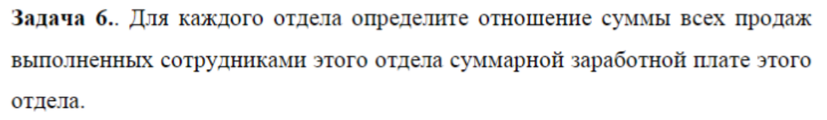
Запрос:
select department_name, sum(oi.quantity * oi.unit_price)/sum(e.salary) as _output
from departments d left outer join
(employees e join
(
order_items oi join orders o using(order_id)
)
on (salesman_id = employee_id)
)
using(department_id)
group by department_name

Вывод:
department_name |_output |
--------------------+-------------------+
Human Resources | |
Shareholder Services| |
Marketing | |
IT Support | |
NOC | |
Operations | |
Benefits | |
Contracting | |
IT Helpdesk | |
Payroll | |
Sales |17.7348439725495274|
Задание 7
Условие:
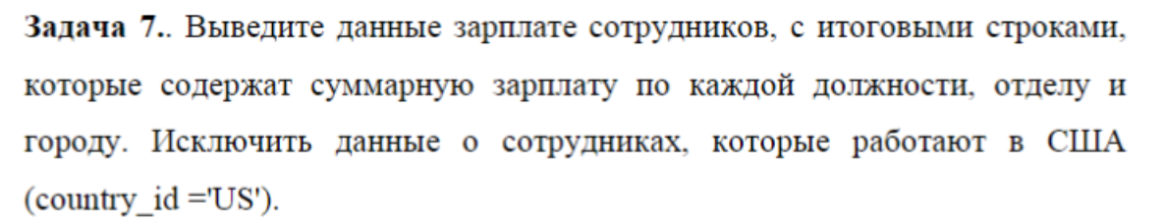
Запрос:
select sum(e.salary) as sum,e.job_id, d.department_id,l.city
from employees e join
(departments d join locations l using (location_id))
using (department_id)
where l.country_id != 'US'
group by e.job_id, d.department_id, l.city
Вывод:
sum |job_id|department_id|city |
---------+------+-------------+-------+
234500.00|SA_REP| 80|Oxford |
6500.00|HR_REP| 40|London |
61000.00|SA_MAN| 80|Oxford |
10000.00|PR_REP| 70|Munich |
13000.00|MK_MAN| 20|Toronto|
6000.00|MK_REP| 20|Toronto|

